Exploring Job-Hunting and Suicide:
Similarities and Differences between Japanese and American University Students

Kanako Miyake

California State University Monterey Bay

Abstract

For Japanese university students, job-hunting is important. Japanese society tends to hope that the students will get a job before graduation. Thus, many students feel pressure about job-hunting. In Japan, the suicide rate from failing to get a job is higher than any other country and is a serious problem. For American university students, however, failing to get a job is not as detrimental. In my study, I researched different perspectives on job-hunting and on suicide related to failing to get a job among American and Japanese university students. I researched what factors (including media) contributed in deciding to commit suicide among university students who have failed to get a job, as well as comparing Japan and the U.S. with what practice universities currently employ for suicide prevention.

Introduction
While growing up in Japan, I noticed that many Japanese university students take job-hunting very seriously. On the other hand, a majority of my American friends say that they are unsure of what they will do in the future and will find their future career after graduation. It was because of this that the differences in perspectives on job-hunting were very interesting to me.

- Significance of the Study
The reason why I chose this topic is that in Japan, getting a job is very important for university students. While growing up in Japan, there have been many cases regarding students committing suicide due to failure of obtaining a job. This puzzled me and led me to explore deeper into why do they choose to commit suicide even though they are still young and have a potential future? The purpose of this study is to find the causes of these particular suicides and the possible solutions to prevent it.

- Research Questions:
- What are the factors that contribute to committing suicide among university students who failed to get a job?
- In what ways does media contribute to suicide in the U.S. and Japan?
- What policies are universities currently employing for suicide prevention?

- Review of Literature
3.1. The suicide rate in Japan and the US
When discussing with some of my foreign friends about suicide, most of them are under the impression that Japan has a notorious reputation of people committing suicide. According to the American Association of Suicidology, the suicide rate in 2010 shows that, for every 100,000 people, about 14 people in Japan committed suicide whereas about 12 people did so in the U.S. We can see that the suicide rate in Japan is higher than in America (Graph 1).
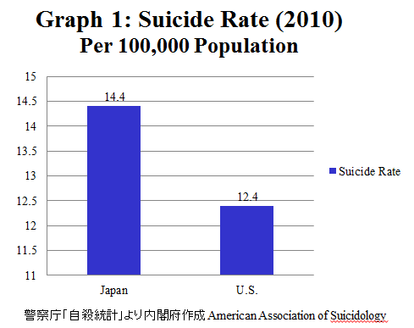
The following graph 2 indicates that suicide between the ages of 20 and 24 are generally, considered as college students. This shows that per 100,000 people about 21 people in Japan committed suicide and about 12 people did so in the U.S. Again, the suicide rate among 20 to 24 years old in Japan is higher than in America.
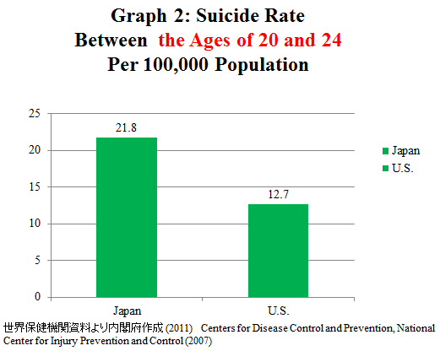
As you can see from the next graph (graph 3), the number of suicides resulting from job-hunting among 20 year olds in Japan continued to proliferate from 2007 to 2010. Currently, the suicide rate has remained consistent without any major fluctuations.
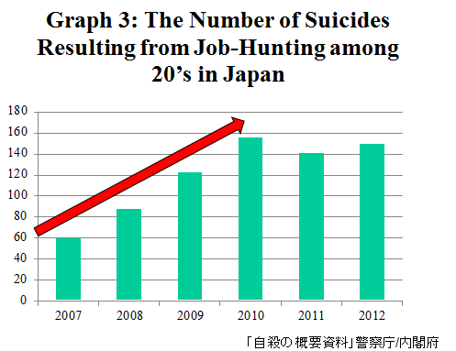
3.2. The Contributing Factors to Suicide
In Japan, health problem is the most prominent reason for someone to commit suicide, followed by financial stress and family issues. On the other hand, in the U.S., the main factors are depression, mental disorder, and substance-abuse disorder. More than 90 percent of people who die by suicide experience these factors (Moscicki, 2001).
The graph 4 shows that the employment rate before graduation in Japan is higher than in America.
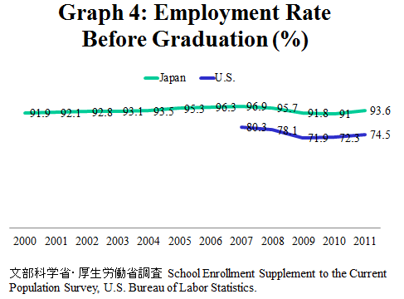
The graph 5 indicates that jobs-to-applicants ratio in Japan. After the bursting of the bubble economy in 1991 and the bankruptcy of Lehman Brothers in 2008, the job-to-application rate was decreasing. Thus, the job-to-application rate is constantly changing based on the economic condition.
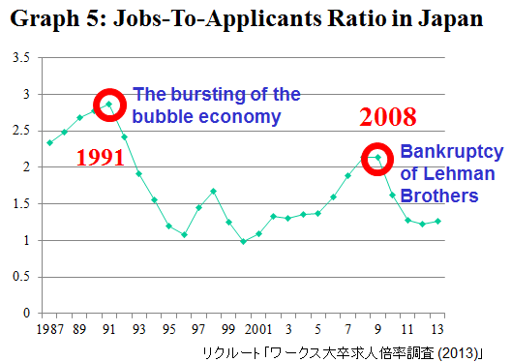
3.3. The Job-hunting Relation to Suicide in Japan
Job-hunting in Japan is very different from in the U.S. The biggest difference is employment of “new graduates” for graduating students, basically there are 2 patterns. These patterns are: the need to find a job before graduating university to keep “new graduates” status and the postponement of graduation if they fail to obtain a job.
Chart 1 shows the ideal timeline of job-hunting in Japan. April is considered as a new academic year. During the month of June, Junior students start applying for internships; analyze themselves, and research career field and companies which they plan to apply for once the job-hunting season starts. In August, students begin attending company information sessions. Once the job-hunting season opens in November, many college students are rushing to apply in hopes of receiving a job interview around February. The most successful result that one can obtain during this time from job-hunting is to receive “informal job offers” around April when they become seniors.
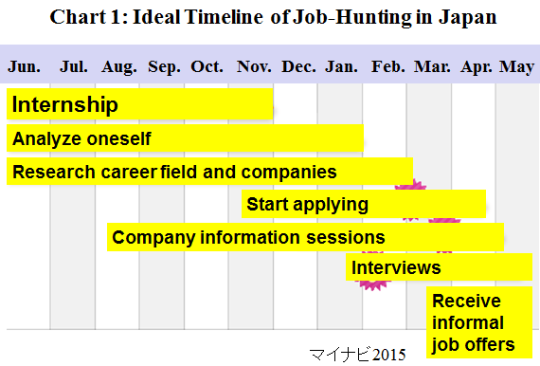
According to graph 6, we can see more than one-fourth of university students applied to more than 100 companies.
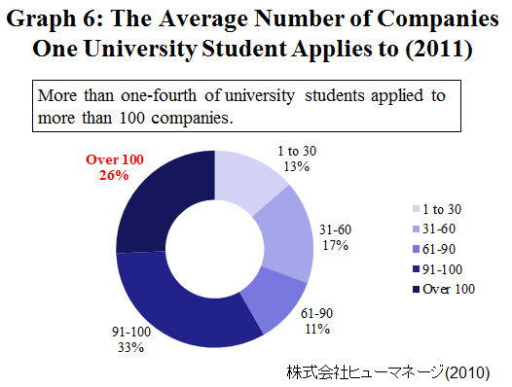
With Japan being one of the most internationally traded with countries in the world, particularly with America, a demand for those who have a higher level of proficiency in English, as well as experience with the American culture, has an upper advantage over those who don’t. One of my former classmates, which I spoke to, started job-hunting during his senior year but he wasn’t successful even after applying to over 100 companies. He also spent more than $10,000 for transportation because big career fairs or job interviews are usually held in big cities. He felt inferior compared to others like him. Through his failure of securing an informal interview, he postponed his graduation and decided to come to CSUMB as an exchange student. Upon returning to Japan after his study abroad experience, he returned to job-hunting and successfully landed an informal job offer.

  - The Historical Background Relation to Suicide in Japan
Japan’s history of suicide goes as far back as the samurai era. Suicide did not always have a negative connotation to it. “Seppuku”, also known as a ritual suicide, was considered to be one of the highest forms of atonement, in other words, Samurai culture. Samurai’s were allowed to do “Seppuku” in order to die with honor voluntarily. Seppuku is the act of cutting one’s stomach where it is believed to have one’s sprit. The purpose of Seppuku is to take responsibility for oneself or vassals, and to keep the honor of their family name. I believe that this Samurai culture has something to do with the suicide rate of Japanese university students. Failing to get a job is shameful for them. They also tend to blame themselves for failure and ashamed or embarrassed to confront their parents and society by failing to get a job.

  - The Methods of Prevention
With the proliferation of the suicide rate in Japan, Japanese university’s created a support system to aid students in obtaining a job in Japan. I spoke with Shinya Sakamoto, a career advisor at the Career Development Center in my home university, at Okayama University. He states that there are 2 main reasons why students fail to get a job. The first reason is a lack of skills needed for interviews and passing written exams. To remedy this, he teaches students the skills and knowledge they need for successful job hunting. The second reason is that students hold unrealistically high standards as their ideal career. In this case, he encourages the students to explore a variety of different job fields. He states that career advisors direct students toward new opportunities. On the other hand, psychological counselors listen to their ideas and difficulties.
I also visited the Career Department in CSUMB and asked Thomas Rogers, one of the career advisers, about their career support system. He teaches how to write resumes, practice job interviews, and holds career fairs on campus. CSUMB has connections with local companies and organizations. He also offers lectures to freshman to introduce career development plans. For example, these are basic guidelines each academic year: Freshmen study and discuss major options, sophomore research target careers, juniors do an internship related to their field, and finally, seniors improve their resumes and practice interviewing. CSUMB also had an event for suicide prevention & awareness.

- Research Method
61 university participants who are 30 Japanese and 31 American students took my survey. Mainly most of them were juniors and seniors.

- Results
5.1. Research question 1: What are the factors that contribute to committing suicide among university students who failed to get a job?
According to graph 7, when survey participants where posed with the question, “Is committing suicide okay under certain circumstances?” Japanese students answered equally, however, more American students do not accept committing suicide and the circumstances are as follows: “If you are acting to save other people’s lives, knowing that your actions will lead to your own death,” and “When suicide is better than living.”
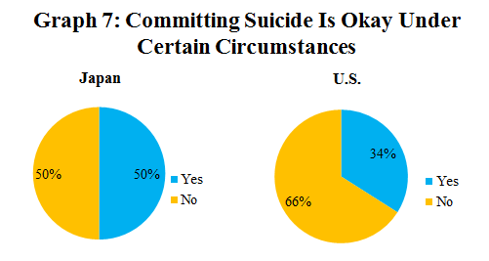

As you can see from graph 8, More Japanese students are worried about getting a job than Americans.
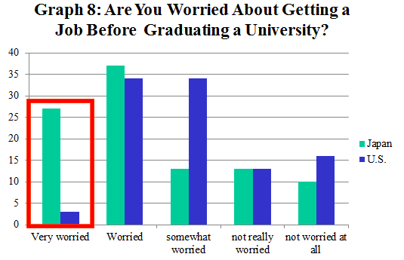
Graph 9 shows that Japanese students plan to apply to many more companies than American students do.
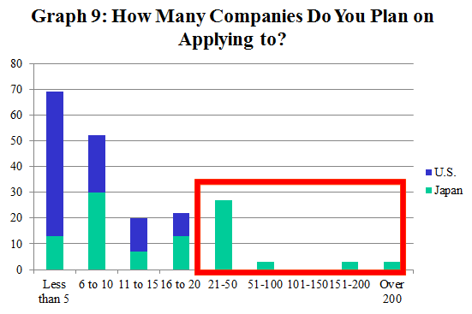
According to graph 10, Japanese students recognize the importance of these actions more than American students.
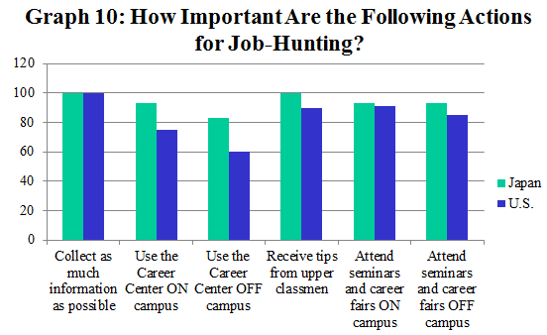
To my surprise, more than 90% of Japanese students are concerned about failing to get a job whereas American students answer equally according to graph 11.
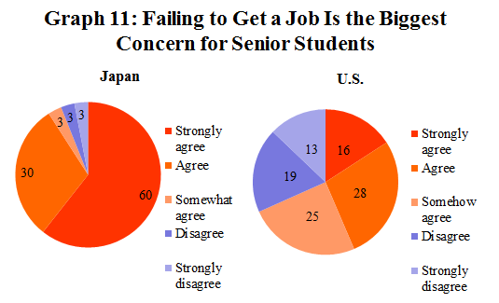
In this case study, the question posed to survey participants was, “You failed to get a job before graduating the university. You already applied to 200 companies, but you still cannot get a job. How do you feel in this situation?” More Japanese students tend to feel they are not needed in society and they feel they are unlucky. American students also feel they are unlucky but they show positive attitudes toward applying to more jobs according to graph 12.
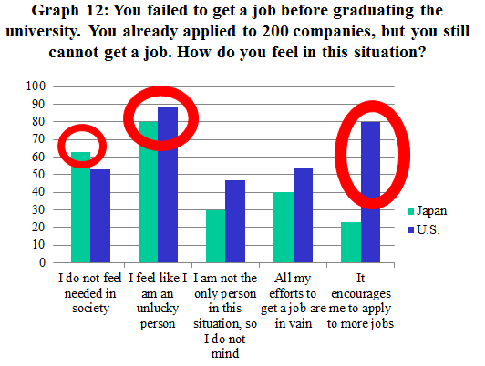
Who do you blame in the same situation? The graph 13 shows more than 80% of Japanese students blame themselves, while oppose to America, where 90% of American students blame the economic situation.
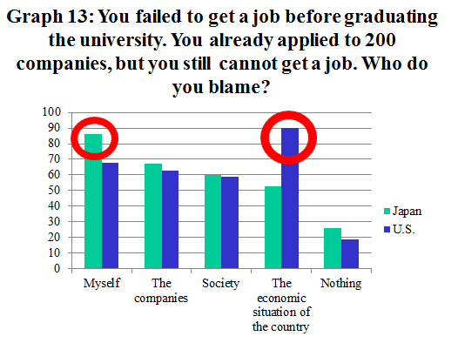
Survey results show that: Japanese students tend to believe that committing suicide is acceptable under certain circumstances, are worried about getting a job, plan to apply many more companies, and further recognize the importance of job-hunting, and blame themselves when they fail to get a job.

5.2. Research question 2: In what ways do media contribute to suicide in the U.S. and Japan?
As you can see from the graph 14, both Japanese and American students think that Socia1 Networking Services are the most influential factors.
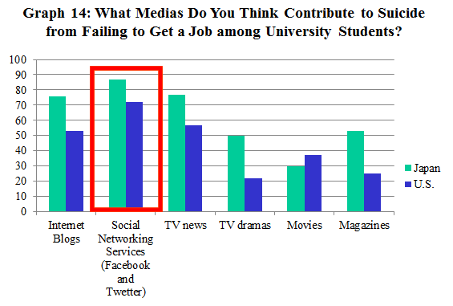
Some American Students who answered differently said that they think media isn’t a major factor. Family concerns, financial issues, and academic problems are common issues that pertain to suicide more than social media, which lowers the self-esteem in general.
To my surprise, most students have never seen these kinds of websites or blogs according to graph 15.
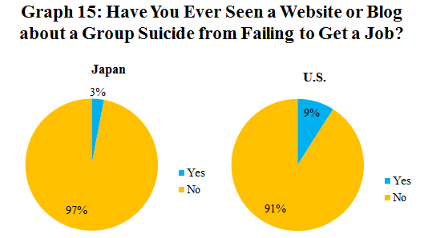
According to the survey results, Almost 90% of Japanese students think that Social Networking Services are an influential factor. Most of the factors are related to suicide for Japanese. For American students, media does not have an influence on suicide from failing to get a job.

5.3. Research question 3: What policies are universities currently employing for suicide prevention?
As you can see from the graph 16, more than 60% of Japanese students do not know their university services.
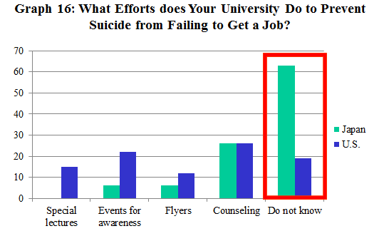
Again, this graph shows that most students have not used these services according to graph 17.
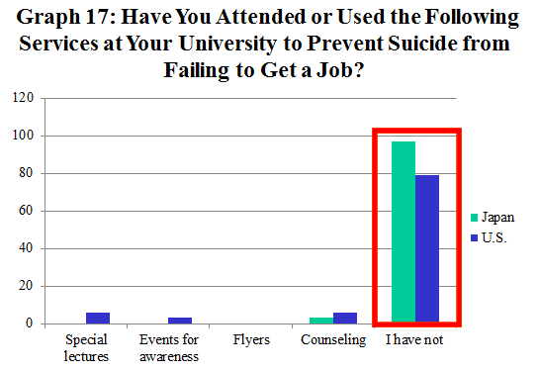
The graph 18 shows that only 3% of Japanese students think that their university puts effort towards suicide prevention.
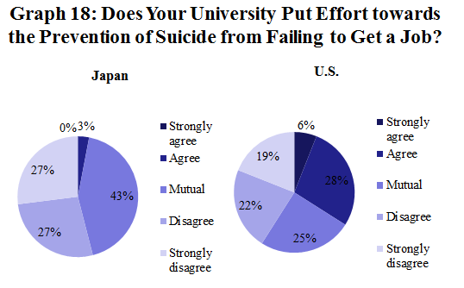
My research summary is as follows: Most students have not used university services. Many Japanese students do not know about those services and they don’t think their university puts effort towards suicide prevention.
- Conclusion
Japanese students tend to be over anxious about getting a job when they graduate. So, Japanese companies should change their hiring criteria or guideline and hire students of different education status. Furthermore, Social Networking Services were considered to be a major influence on suicide for both Japanese and American students. From my point of view, education of information literacy with ethical usages is key. Finally, Japanese students should be encouraged to use more of the university services effectively.

- Limitation of the study
The participants were students from my home university in Japan and CSUMB. So the results may not be generalized to the entire university population in Japan and the U.S.

- Future Study
I would like to compare rural and urban areas and find reasons for Japanese current hiring system “new graduates.” I also want to explore the difference between small and large companies in terms of the hiring system in the future.

Reference

Specific page of the website

Asiaone. (2012). Record high for youth suicide in Japan. Singapore Press. Retrieved From
http://news.asiaone.com/News/AsiaOne+News/Asia/Story/A1Story20120310-332649.html

Cabinet Office. (2013). Policy on Cohesive Society , Retrieved From
http://www8.cao.go.jp/jisatsutaisaku/whitepaper/w-2013/pdf/index.html

Hori, M. The Grave Problem of University Student Suicides How to Deal with Young People Who Want to Die. The Japan News. Retrieved From
http://www.yomiuri.co.jp/adv/wol/dy/opinion/society_091228.htm

Shimizu, Y. (2013). 視点・論点 「“就活自殺”の背景に迫る」 Retrieved From
http://www.nhk.or.jp/kaisetsu-blog/400/167020.html

Tara, P. (2013) Suicide Rates Rise Sharply in U.S. The New York Times. Retrieved From
http://www.nytimes.com/2013/05/03/health/suicide-rate-rises-sharply-in-us.html?_r=0

U.S.A. SUICIDE: OFFICIAL FINAL DATA (2010). Retrieved From
http://www.suicidology.org/c/document_library/get_file?folderId=262&name=DLFE-636.pdf

Yamaguti, M. (2013). Japan Suicide Rate Still Among The World's Highest Due To Low Job Prospects. The Huffington Post. Retrieved From
http://www.huffingtonpost.com/2011/03/04/japan-suicide-rate-still-_n_831430.html

ヒューマネージ. (2010). Retrieved From
https://www.humanage.co.jp/company/images/20100805_release_website.pdf

マイナビ(2015). Retrieved From http://job.mynavi.jp/conts/2015/schedule/

リクルート (2013).「ワークス大卒求人倍率調査（2013年卒）」Retrieved From
http://souken.shingakunet.com/college_m/2012_RCM175_48.pdf

